Why and How Your Body Makes Millions of Red Blood Cells Every Minute

Your red blood cells are highly specialized to carry oxygen from your lungs to the rest of your body. Each red blood cell is packed full of hemoglobin, the protein molecule that
carries oxygen. A red blood cell has:  - millions of molecules of hemoglobin  - no nucleus, ribosomes, mitochondria, or other organelles.  1a. Describe the characteristics of red blood cells that allow them to carry maximum oxygen to the other cells in your body. | 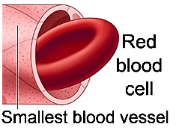

1b. An average red blood cell only lasts about four months before it becomes too damaged to survive. In contrast, many cells in your body live for years. How could the specialized characteristics of red blood cells contribute to their inability to live beyond about four months?

Since each red blood cell only lasts a few months and there are trillions of red blood cells, roughly 2 million of your red blood cells die every second.

2a. How many replacement red blood cells do you think your body makes per second?

2b. What would happen if your body did not make red blood cells throughout your life?

The process of making new red blood cells starts with blood stem cells in your bone marrow. Blood stem cells have normal organelles, including a nucleus, ribosomes and mitochondria. Blood stem cells do not contain hemoglobin.  3. What changes are needed to convert blood stem cells to red blood cells? (Hint: Review the differences between the characteristics of blood stem cells and red blood cells.) | 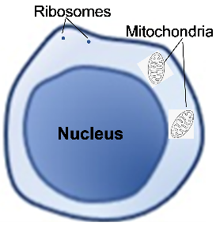

When a blood stem cell divides, one of the daughter cells becomes a replacement blood stem cell. The other daughter cell divides repeatedly to produce cells that develop into red blood cells or other types of blood cells. Blood stem cells and their daughter cells divide by mitosis.
4. Repeated mitosis produces lots of daughter cells. Mitosis produces daughter cells with  - no chromosomes  - half the number of chromosomes in the original cell  - the same chromosomes as the original cell  5. Your body has fewer than 200,000 blood stem cells, but your body makes millions of red blood cells every minute. Why don’t you run out of blood stem cells? | 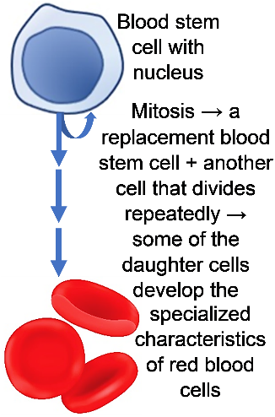

To learn about the general process that converts stem cells to specialized cells like red blood cells, view the video, Cell Differentiation (https://www.youtube.com/watch?v=gwAz_BtVuLA).

6a. What is cell differentiation?

6b. When does cell differentiation occur? only in embryos ___ only in children ___
only in embryos and children ___ only in adults __ in embryos, children and adults ___

6c. Explain why cell differentiation is needed at the stage or stages when it occurs.

7a. Cells that are developing into red blood cells make hemoglobin, and other types of cells don’t make hemoglobin. Which of the following statements correctly explains why?
- Only stem cells that are developing into red blood cells have hemoglobin genes.
- All types of stem cells have hemoglobin genes, but transcription of hemoglobin genes only occurs in cells that are developing into red blood cells.

7b. Explain your reasoning.

We will investigate how synthesis of hemoglobin proteins is turned on during differentiation of red blood cells. As background, we should review how a gene in the DNA provides the instructions for making a protein.
8a. Fill in each blank with one of these terms:  mRNA, proteins, ribosomes, RNA polymerase.  During transcription of a gene in the DNA, the enzyme,  _______________________, makes ________.  During translation of an mRNA molecule,  _________________ make ________________. | 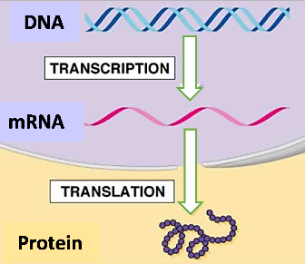

8b. This figure shows the enzyme RNA polymerase carrying out transcription. This enzyme copies the information in a gene to  an _________ molecule.  (DNA/mRNA)  8c. Fill in the blanks in this figure to label the DNA and mRNA. | 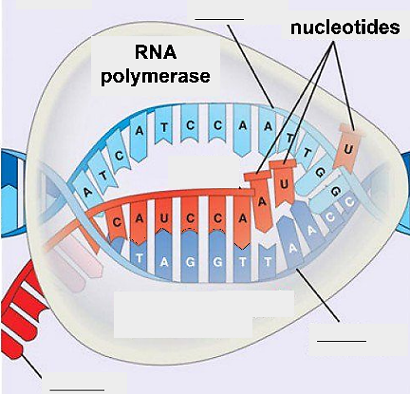

8d. This figure shows a ribosome, which is beginning to make a protein. The ribosome is using the information in mRNA to  determine the sequence of ______________ ___________ in the protein. | 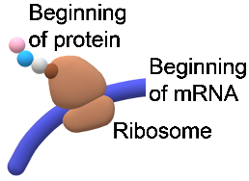

9. During cell differentiation, how do you think the synthesis of hemoglobin proteins is turned on?

Transcription of the hemoglobin gene is turned on in a cell that is differentiating to become a red blood cell. To understand how, you will need to learn about the structures of chromosomes and genes.

Each chromosome contains a very long molecule of DNA, which is wound around histone proteins. The figure below shows that the DNA of a gene plus the associated histone proteins can take two different forms.
- On the left, the DNA plus histone proteins in the region of a gene are bunched together. As a result, RNA polymerase cannot reach the DNA of the gene, so there is no transcription.
- On the right, acetyl groups have been added to the histone proteins, so the DNA plus histone proteins are more spread out. This allows RNA polymerase to reach the DNA.

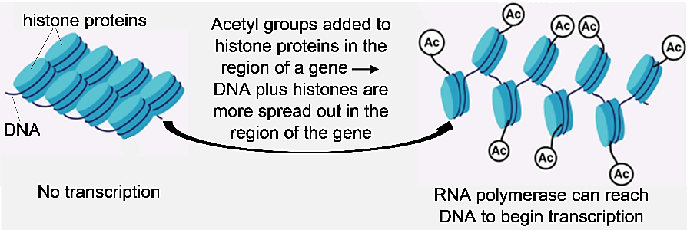

10a. Think about a cell that is differentiating to become a red blood cell. Circle the drawing in the above figure that shows the hemoglobin gene during production of hemoglobin proteins.

10b. Explain your reasoning.

Adding acetyl groups to the histone proteins that a gene is wound around is an example of an epigenetic change. In general, epigenetic changes affect the rate of transcription of a gene by adding or removing side groups on the DNA of a gene or the histone proteins that this DNA is wound around. Epigenetic changes play a crucial role in cell differentiation.

11. What is an epigenetic change that contributes to the differentiation of red blood cells?

This figure shows that each gene has two parts. When a transcription factor binds to the regulatory part of the gene (A), this recruits RNA polymerase to begin transcription of the coding part of the gene (B).

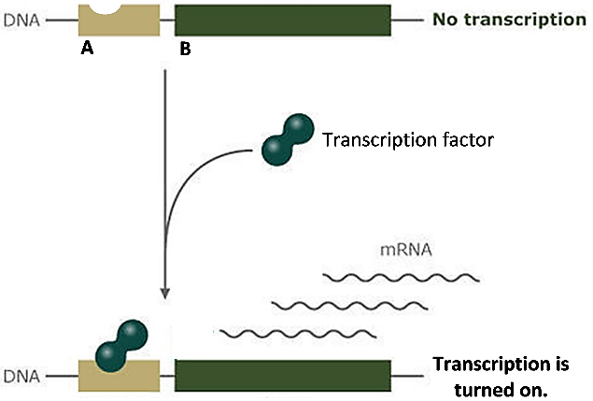

12a. In the above figure, circle the transcription factor bound to the regulatory part of the gene.

12b. After a transcription factor binds to the regulatory part of the gene, which enzyme carries out transcription?

13. Explain how the combination of an epigenetic change and the transcription factor for the hemoglobin gene results in the production of hemoglobin proteins. | 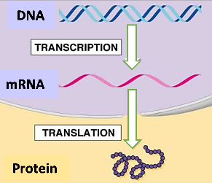

14. Near the end of the differentiation of red blood cells, the nucleus, ribosomes and mitochondria are evicted from each developing red blood cell. Why is it useful for the eviction of these organelles to be postponed until near the end of the differentiation of red blood cells?

2 IMA

By Dr. Ingrid Waldron, Dept Biology, Univ Pennsylvania, © 2025. This Student Handout and Teacher Notes (with learning goals, instructional suggestions, and background biology) are available at https://serendipstudio.org/exchange/bioactivities/RedBloodCells.

